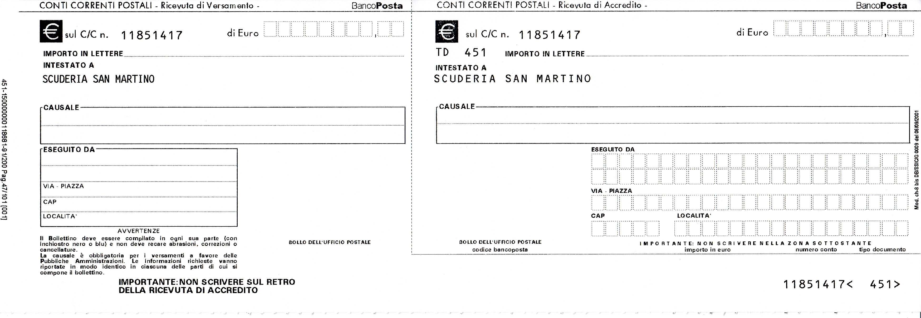

9 0 0 0 9 0 0 0

MATRA-Rinnovo Scuderia San Martino MATRA - Rinnovo Scuderia San Martino

________________________________________________________________________________________________________________________________________

